Week 1
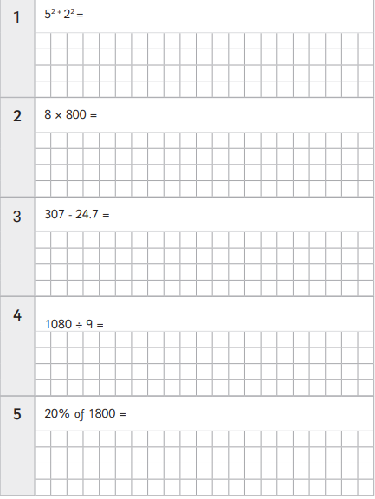
5² - 4 x 5 =
557 x 26 =
65.9 + 4 =
6392 ÷ 100 =
4
of 18 =
- =
$$\frac{5}{6}$$
of 18 =
6
7
8
9
10
735 x 1,000 =
$$\frac{3}{8}$$
of 18 =
of 48 =
60 x 40 =
456,372 + 43,734 =
5684 ÷ 4 =

Week 2
3(5-3) + 2³ =
356 x 28 =
1.6 + 4.89 =
90 ÷ 100 =
2$\frac{2}{5}$
of 18 =
- =
$$1\frac{1}{3}$$
of 18 =
6
7
8
9
10
448 x 100 =
$$\frac{2}{5}$$
of 18 =
of 40 =
500 x 0.5 =
43,940 + 903,856 =
5432 ÷ 13 =

Week 3
6² – 10 ÷ 5 =
788 x 44 =
$$\frac{5}{6}$$
793 ÷ 13 =
79 ÷ 10 =
2$\frac{3}{7}$
of 18 =
+ =
$$3\frac{9}{14}$$
of 18 =
6
7
8
9
10
$$\frac{3}{4}$$
793 ÷ 13 =
x
1000 x 98 =
$$\frac{4}{7}$$
of 18 =
of 35 =
3 x 8000 =
669,001 – 56,777 =
1435 ÷ 7 =

Week 4
2 + 4 x 2 =
4127 x 46 =
$$2\frac{3}{8}$$
793 ÷ 13 =
65 ÷ 1000 =
$$3\frac{2}{5}$$
of 18 =
- =
$$2\frac{3}{4}$$
of 18 =
6
7
8
9
10
3
x
9.8 x 1,000 =
$$\frac{7}{9}$$
of 18 =
÷ 5 =
60 x 90 =
531,933 – 208,382 =
6932 ÷ 14 =

Week 5
5(6) + 3 x 3 =
508 x 84 =
$$3\frac{1}{3}$$
793 ÷ 13 =
678 ÷ 1000 =
1$\frac{5}{8}$
of 18 =
+ =
$$3\frac{7}{16}$$
of 18 =
6
7
8
9
10
4
x
100 x 0.27 =
$$\frac{4}{7}$$
of 18 =
÷ 6 =
4 x 900 =
5,432 + 286,803 =
5321 ÷ 11 =

