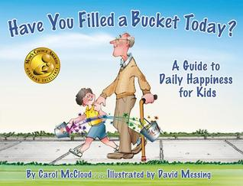
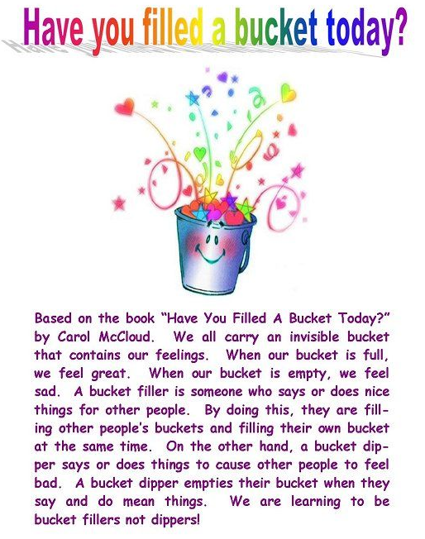
The children have really enjoyed reading this story and sharing their ideas about how they can be bucker fillers!
If your child has filled someone’s bucket and you are really proud of them, please complete a bucket to explain how your child has been a ‘bucket filler’ and send it to your child’s teacher via email.
We have attached bucket templates which you can use to record your child’s acts of kindness on a separate document.

