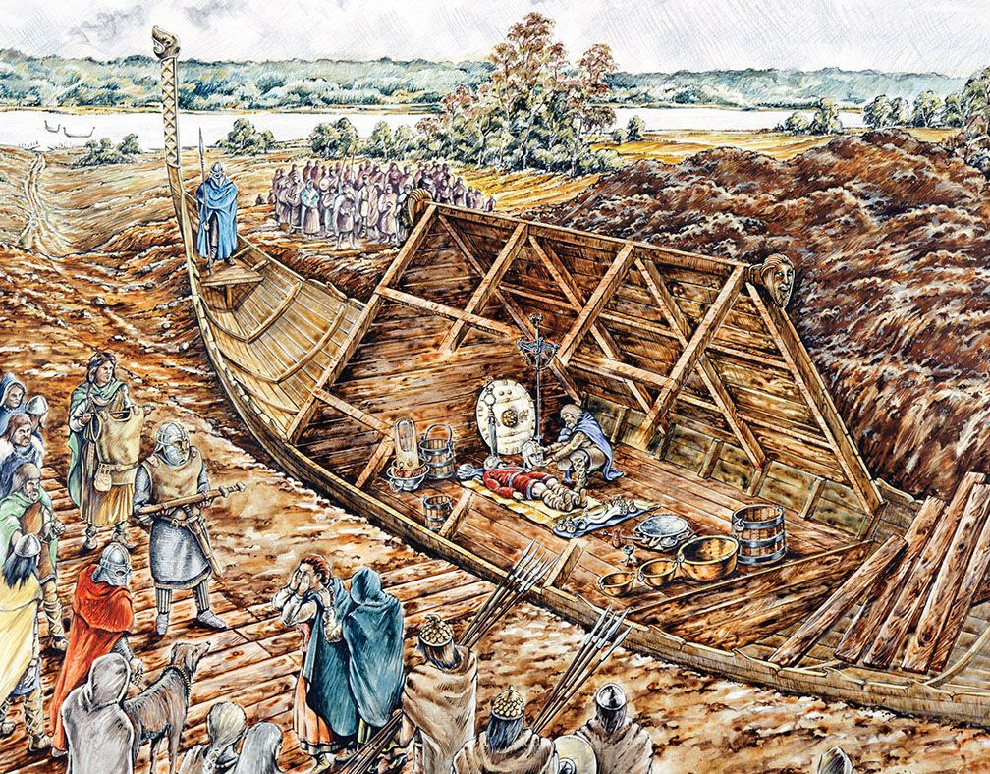
English
In English this term, the children will be delving into books, relating to Ernest Shakleton and his adventures to Antarctica. Year 5 will be exploring the Endurance in detail as well as Shakleton himself, using role play this term to help us write narratives and biographies about the explorer and his endeavours.

Physical Education (PE)
This term in PE, Year 5 will be developing their cricket skills through a range of fun and engaging activities. The children will learn and practise the key skills of batting, bowling, catching and fielding, while also improving their teamwork, communication and sportsmanship. As the unit progresses, pupils will apply these skills in small-sided games, developing their understanding of tactics, rules and game strategies. We will encourage all children to participate confidently, challenge themselves and demonstrate resilience, respect and fair play throughout their learning.

On the Move!
Art
This term, the children will be developing their skills in drawing. They will be expressing their emotion through line and creating depth to their drawings and printing images, whilst learning how drawings can tell a story.
Latin
This term, children will be learning more about Latin tenses in verbs and identify similarities in words. They will explore Roman towns as well as travel in the Roman Empire.
Computing
In computing, we will be developing the children’s understanding of coding. They will plan, create and debugging algorithms. They will begin to understand what a function is and how they work in code. Children will learn about different variable types and how they are used.
Music
Children will be exploring how music brings us together. Within this unit, they will be learning about melody lines and harmonies. Children will explore voices singing melodies and the instruments that are chosen to create harmonies.
Religious Education (RE)
Our Big Question for Term 1: What does it mean if God is loving and holy? We will expand upon prior knowledge and develop our understanding of God as well as linking this to bible stories.
RHE
We will be learning about the living in the wider world. The children will be exploring what it looks like to be a citizen in their country, what their responsibilities are and the idea of rewards and consequences.
History
Our history topic is ‘Anglo Saxon Britain.’ We will be learning about where different invaders and settlers came from and went to. We will be learning about migrations between kingdoms in England and later on focusing on the Kingdom of Mercia.

Geography
The children will be learning about California and the water cycle. Through their growing understanding of where water comes from an is stored, the children will begin to understand why California is running out of water. By the end of the topic, children will be able to identify factors which affect the drought in California.

Mathematics
In Maths, the children will be focusing on place value before moving on to addition and subtraction. This term’s learning will build upon concepts taught last year and will ask the children to apply their understanding to numbers up to a million as well as roman numerals. The children will be working with four-digit numbers using the column method to add and subtract. We will be developing their mental strategies and rounding skills
Science
Our topic in science is ‘Animals Including Humans.’ We will be learning about how humans and animals change over time and how we can investigate these changes, we will be studying animals and animals traits and learning how we study and find out about differences between animals.
.

