Friday 1st May 2026
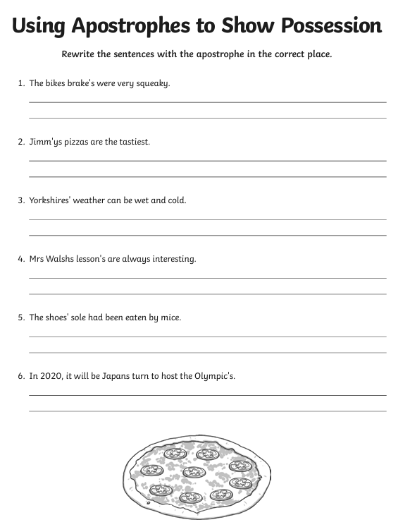
English Homework

