PTA Online Auction 2026

The PTA Online Auction goes live today Monday 27th April at 6pm.

The Auction website: Online Auction 2026

We have been overwhelmed by the huge generosity of staff, PTA members and the local community. Thank you so much for all your support. You will find lots of amazing items such as tickets for days out to Drusilla’s, Godstone Farm, Wildwood, Willows Birds of Prey and many many more! Yoga, Paddleboarding and lots of experiences such as wine and gin tours and activities for children! Also, there is a chance to be Headteacher for the day!

You can view the website without creating a log in. If you wish to bid on an item the website will ask you for an email address and to create a password to register with the auction. From there you will receive notification about the item you have put a bid on if you are outbid and want to place another bid or if you have won the item and then the details of how to pay.

The auction page looks like:

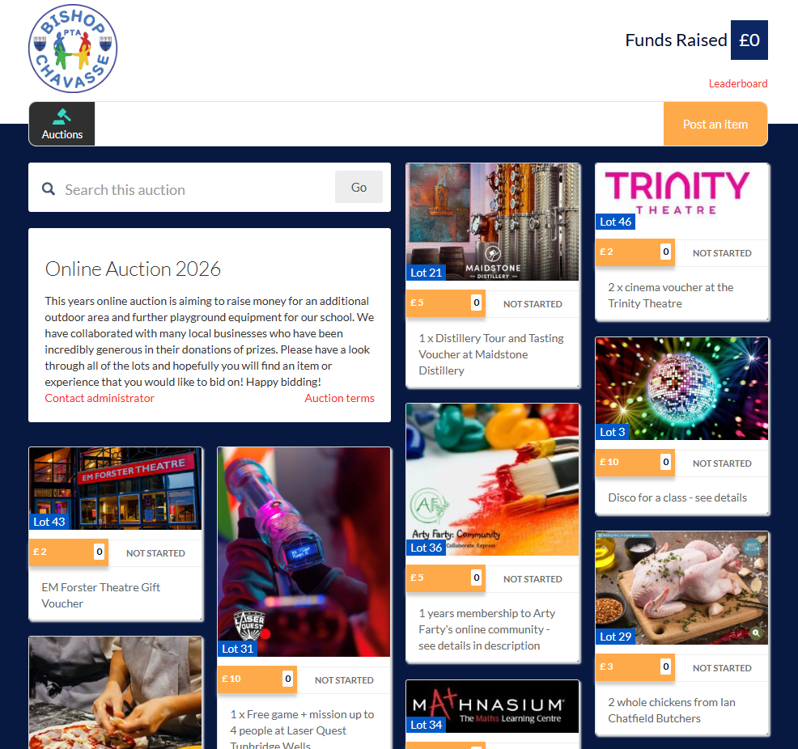

To bid on an item click on the item and this will take you through to the bidding page:

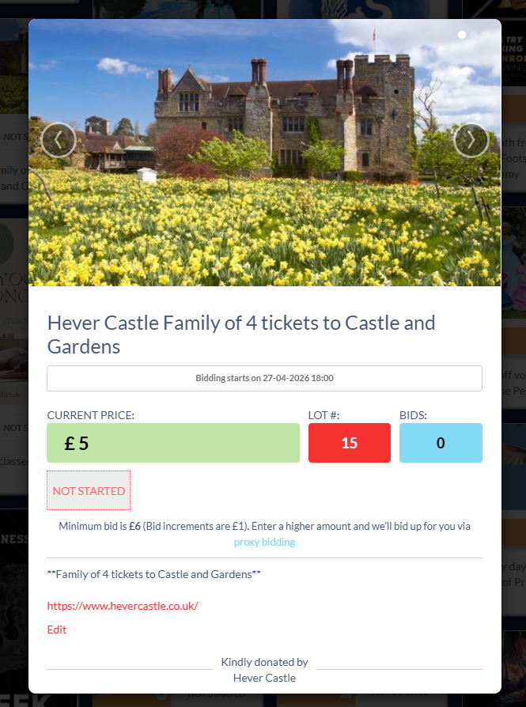
This will say ‘Place Bid’ when the auction starts
There will also be an option to Proxy bid underneath this option. Please read further regarding Proxy bidding.

Proxy bidding means that this is the maximum bid that you want to put in for an item. This means that if you put in a starting bid for an item at £5 and only want to pay a maximum of £10 that if further bids are made at £6, £7 then your bid will automatically be added by a £1 increment until it reaches the top of your proxy bid. If you are outbid over your proxy bid you will receive an email notification to inform you of this and give you the option to bid again.

If you win the item, you will then be emailed to say that you have won the bid and it will then ask you for payment before you then receive the item.

Good luck and happy bidding!

Bishop Chavasse PTA

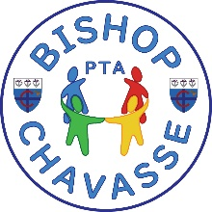

P.S. Don’t forget - you only have 7 days. Bidding will close at Sunday 3rd May at 9pm! Don’t miss out!

