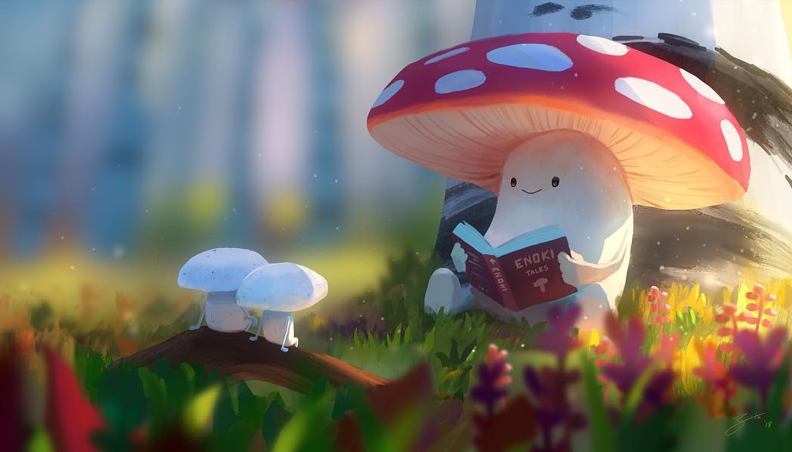

* What’s happening here?
* What do you think the larger toadstool is reading about?
* Write some sentences about the picture.

Challenge

Write a story that the toadstool could be telling to the smaller mushrooms.