

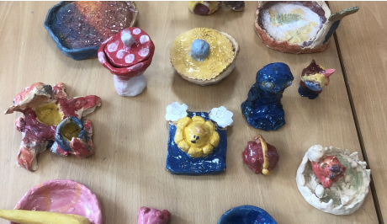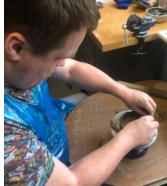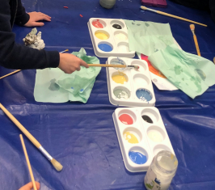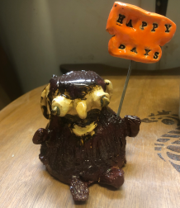

Dear Parent / Carer,

**After school pottery club**

Bishop Chavasse Primary School is running a pottery club for pupils in Years 2-6. KisKlay will explore different ways we can use clay, teaching different techniques and the use of pottery tools. Generally we will be making two projects per term, two weeks of creating and one week of glazing. I hope the children will benefit hugely from working with clay, this will hopefully give them more confidence and help their busy minds relax after a long day in the classroom. I’m looking forward exploring and making little projects with them.

Day: Fridays

Time: 15:30 - 16:30

Cost: Term 1 (7 weeks): £42

Please fill out and return the form below, once you receive a confirmation of place then payment must be made within 24 hours of confirmation. Lessons will take place in the new STEAM room. I only have limited spaces, so please book asap. Please text or email me confirmation and any questions you may have. Payment may be done by Bank Transfer. I shall confirm place by text/email.

Many Thanks

Jette Kisendal, owner of KisKlay

07790025432 [kisklay11@gmail.com](mailto:kisklay11@gmail.com)

------------------------------------------------------------------------------------------------------------------

**Pottery Club – Years 2-6**

I would like __________________________in class _______to take part in after school pottery club.

Mobile/Email No ______________________________________________________________ Signed____________________________________________Date_______________________

Print Name____________________________________________________________________